|  |  |
| --- | --- |
|  | Желание |
| Учеба | 1 |
| Игра | 2 |

**Вариант 5. Задача 1**

P = 2*x2 + 1*x1 (1)

Неотрицательное время

x1 >= 0 и x2 >= 0 (2)

Часов в день, 10

x1 + x2 ~ 10 (3)

Время на игру не должно превышать время учебы

x1 >= x2 (4)

Если выполнять все задания, то на игру будет не более 4 часов

x2 <= 4 x1 >= 6 (5)

**Задача 2.**

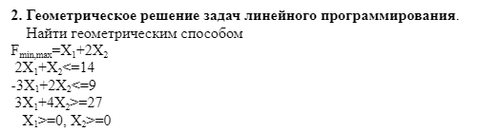

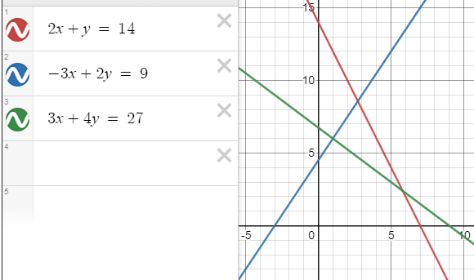

X*min

X*max

c

f*max = f(x*max), f*min = f(x*min)

y = 14 – 2x | 4.5 + 1.5x = 14 – 2x | -9.5 = - 3.5x | x = 9.5/3.5 = 2.714

2y = 9 + 3x | y = 4.5 + 1.5x | y = 14 – 2*2.714 = 8.572 вторую на калькуляторе посчитал.

F*max = 2.714 + 2 * 8.572 = 19.858 F*min = 5.8 + 2 * 2.4 = 10.6

**Задача 3.**

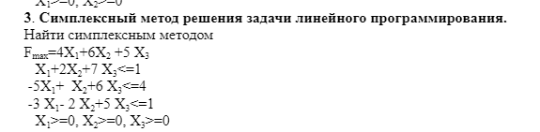

x1+2x2+7x3 +x4 + + = 1  
-5x1+x2+6x3 + +x5  + = 4  
-3x1-2x2+5x3+ + + x6  = 1

|  |  |  |  |  |  |  |  |  |  |  |  |  |  |  |  |  |  |  |  |  |  |  |  |
| --- | --- | --- | --- | --- | --- | --- | --- | --- | --- | --- | --- | --- | --- | --- | --- | --- | --- | --- | --- | --- | --- | --- | --- |
| A = | |  |  |  |  |  |  |  |  |  |  |  |  |  |  |  |  |  |  |  | | --- | --- | --- | --- | --- | --- | --- | --- | --- | --- | --- | --- | --- | --- | --- | --- | --- | --- | --- | | |  |  |  |  |  |  | | --- | --- | --- | --- | --- | --- | | 1 | 2 | 7 | 1 | 0 | 0 | | -5 | 1 | 6 | 0 | 1 | 0 | | -3 | -2 | 5 | 0 | 0 | 1 | | | | | |
| **Базис** | **x0** | **x1** | **x2** | **x3** | | **x4** | **x5** | **x6** |
| **x4** | 1 | 1 | 2 | 7 | | 1 | 0 | 0 |
| **x5** | 4 | -5 | 1 | 6 | | 0 | 1 | 0 |
| **x6** | 1 | -3 | -2 | 5 | | 0 | 0 | 1 |
|  | 0 | -4 | -6 | -5 | | 0 | 0 | 0 |

Есть отрицательные, самый маленький – (-6), значит, в базис идет х2.

Выходит из базиса х4, потому что ½, это самое маленькое число.

|  |  |  |  |  |  |  |  |
| --- | --- | --- | --- | --- | --- | --- | --- |
| **Базис** | **x0** | **x1** | **x2** | **x3** | **x4** | **x5** | **x6** |
| **X2** | 1/2 | 1/2 | 1 | 7/2 | 1/2 | 0 | 0 |
| **x5** | 7/2 | -11/2 | 0 | 5/2 | -1/2 | 1 | 0 |
| **x6** | 2 | -2 | 0 | 12 | 1 | 0 | 1 |
|  | 3 | -1 | 0 | 16 | 3 | 0 | 0 |

Есть отрицательные, самый маленький – (-1), значит, в базис идет х1.

Выходит из базиса х2, потому что 1, это самое маленькое число.

|  |  |  |  |  |  |  |  |
| --- | --- | --- | --- | --- | --- | --- | --- |
| **Базис** | **x0** | **x1** | **x2** | **x3** | **x4** | **x5** | **x6** |
| **x4** | 1 | 1 | 2 | 7 | 1 | 0 | 0 |
| **x5** | 9 | 0 | 11 | 41 | 5 | 1 | 0 |
| **x6** | 4 | 0 | 4 | 26 | 3 | 0 | 1 |
|  | 4 | 0 | 2 | 23 | 4 | 0 | 0 |

Отрицательных чисел нет, значит, это оптимальный вариант.

X1 = 1, x2 = 0, x3 = 0, x4 = 0, x5 = 9, x6 = 4

Fmax = 4*1 + 5*0 + 6*0 = 4

Номер 4.

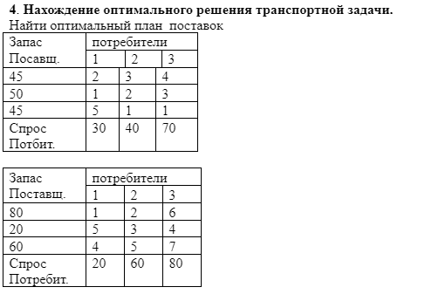

1)30+40+70 = 45+45+50 = 140

2) 20+60+80 = 20+60+80 = 160

1 решение

V1 = 2 v2 = 3 v3 = 4

|  |  |  |  |  |
| --- | --- | --- | --- | --- |
|  | Б1 | Б2 | Б3 | запас |
| А1  U1 = 0 | 2  30 | 3  15 | 4  4 | 45 |
| А2  U2 = 1 | 1  1 | 2  25 | 3  25 | 50 |
| А3  U3 = 3 | 5  -1 | 1  0 | 1  45 | 45 |
| потребность | 30 | 40 | 70 |  |

ab21 = 1

ab31 = -1

ab32 = 0

ab13 = 4

Решение является оптимальным.

2*30 + 3*15 + 2*25 + 3*25 + 1*45 = 275 ед.

2 решение

V1 = 1 v2 = 2 v3 = 3

|  |  |  |  |  |
| --- | --- | --- | --- | --- |
|  | Б1 | Б2 | Б3 | запас |
| А1  U1 = 0 | 1  20 | 2  60 | 6  3 | 80 |
| А2  U2 = -1 | 5  2 | 3 -  0 | 4 +  20 | 20 |
| А3  U3 = -4 | 4  5 | 5 +  6 | 7 -  60 | 60 |
| потребность | 20 | 60 | 80 |  |

ab21 = 2

ab31 = 5

ab32 = 6

ab13 = 3

V1 = 1 v2 = 2 v3 = 4

|  |  |  |  |  |
| --- | --- | --- | --- | --- |
|  | Б1 | Б2 | Б3 | запас |
| А1  U1 = 0 | 1  20 | 2  60 | 6  4 | 80 |
| А2  U2 = 0 | 5  0 | 3  2 | 4  20 | 20 |
| А3  U3 = -3 | 4  4 | 5  0 | 7  60 | 60 |
| потребность | 20 | 60 | 80 |  |

ab21 = 0

ab31 = 4

ab22 = 2

ab13 = 4

1*20 + 2*60 + 4*20 + 7*60 = 640 ед.

Задача 5. Решить задачу коммивояжера

|  |  |  |  |  |  |
| --- | --- | --- | --- | --- | --- |
|  | 1 | 2 | 3 | 4 | 5 |
| 1 | Х | 8 | 4 | 9 | 6 |
| 2 | 6 | Х | 6 | 4 | 8 |
| 3 | 5 | 7 | Х | 6 | 8 |
| 4 | 7 | 5 | 5 | Х | 9 |
| 5 | 7 | 9 | 7 | 7 | Х |

Hi = 4 + 4 + 5 + 5+ 7 = 25

Ищем мин элемент строки и приводим строку.

|  |  |  |  |  |  |
| --- | --- | --- | --- | --- | --- |
|  | 1 | 2 | 3 | 4 | 5 |
| 1 | Х | 4 | 0 | 5 | 2 |
| 2 | 2 | Х | 2 | 0 | 4 |
| 3 | 0 | 2 | Х | 1 | 3 |
| 4 | 2 | 0 | 0 | Х | 4 |
| 5 | 0 | 2 | 0 | 0 | Х |

Hj = 0 + 0 + 0 + 0 + 2 = 2

H = 27.

Теперь тоже самое по столбцам.

|  |  |  |  |  |  |  |
| --- | --- | --- | --- | --- | --- | --- |
|  | 1 | 2 | 3 | 4 | 5 | di |
| 1 | Х | 4 | 0(0) | 5 | 0(1) | 0 |
| 2 | 2 | Х | 2 | 0(2) | 2 | 2 |
| 3 | 0(1) | 2 | Х | 1 | 1 | 1 |
| 4 | 2 | 0(2) | 0(0) | Х | 2 | 0 |
| 5 | 0(0) | 2 | 0(0) | 0(0) | Х | 0 |
| dj | 0 | 2 | 0 | 0 | 1 | 0 |

Сумма констант приведения самая большая у (2:4) и (4:2).

|  |  |  |  |  |  |  |
| --- | --- | --- | --- | --- | --- | --- |
|  | 1 | 2 | 3 | 4 | 5 | di |
| 1 | Х | 4 | 0 | 5 | 0 | 0 |
| 2 | 2 | Х | 2 | 0 | 2 | 0 |
| 3 | 0 | 2 | Х | 1 | 1 | 0 |
| 4 | 2 | Х | 0 | Х | 2 | 0 |
| 5 | 0 | 2 | 0 | 0 | Х | 0 |
| dj | 0 | 2 | 0 | 0 | 0 | 2 |

H = 27 + 2 = 29

Удаляем 4 строку и 2 столбец

|  |  |  |  |  |  |
| --- | --- | --- | --- | --- | --- |
|  | 1 | 3 | 4 | 5 | di |
| 1 | Х | 0 | 5 | 0 | 0 |
| 2 | 2 | 2 | Х | 2 | 0 |
| 3 | 0 | Х | 1 | 1 | 0 |
| 5 | 0 | 0 | 0 | Х | 0 |
| dj | 0 | 0 | 0 | 0 | 0 |

Надо привести строку 2.

H = 27+2 = 29. 29 <=29 нижняя Гамильтонова граница теперь 29

|  |  |  |  |  |  |
| --- | --- | --- | --- | --- | --- |
|  | 1 | 3 | 4 | 5 | di |
| 1 | Х | 0 | 5 | 0 | 0 |
| 2 | 0 | 0 | Х | 0 | 0 |
| 3 | 0(1) | Х | 1 | 1 | 1 |
| 5 | 0 | 0 | 0(1) | Х | 0 |
| dj | 0 | 0 | 1 | 0 | 0 |

3:1

|  |  |  |  |  |  |
| --- | --- | --- | --- | --- | --- |
|  | 1 | 3 | 4 | 5 | di |
| 1 | Х | 0 | 5 | 0 | 0 |
| 2 | 0 | 0 | Х | 0 | 0 |
| 3 | Х | Х | 1 | 1 | 1 |
| 5 | 0 | 0 | 0 | Х | 0 |
| dj | 0 | 0 | 0 | 0 | 1 |

3 строку и 1 столбец

|  |  |  |  |  |
| --- | --- | --- | --- | --- |
|  | 3 | 4 | 5 | di |
| 1 | Х | 5 | 0 | 0 |
| 2 | 0 | Х | 0 | 0 |
| 5 | 0 | 0 | Х | 0 |
| dj | 0 | 0 | 0 | 0 |

…

|  |  |  |  |  |
| --- | --- | --- | --- | --- |
|  | 3 | 4 | 5 | di |
| 1 | Х | 5 | 0(5) | 5 |
| 2 | 0 | Х | 0 | 0 |
| 5 | 0 | 0(5) | Х | 0 |
| dj | 0 | 5 | 0 | 0 |

5:4

|  |  |  |  |  |
| --- | --- | --- | --- | --- |
|  | 3 | 4 | 5 | di |
| 1 | Х | 5 | 0 | 0 |
| 2 | 0 | Х | 0 | 0 |
| 5 | 0 | Х | Х | 0 |
| dj | 0 | 5 | 0 | 5 |

5 строку и 4 столбец (2:5 ы исключаем тут, чтобы избежать подцикла от 5:4, 4:2)

|  |  |  |  |
| --- | --- | --- | --- |
|  | 3 | 5 | di |
| 1 | Х | 0 | 0 |
| 2 | 0 | Х | 0 |
| dj | 0 | 0 | 0 |

2:3 и 1:5 – последние маршруты

Вышли маршруты

4:2, 3:1, 5:4, 2:3, 1:5

Или, если в красивом порядке

4:2, 2:3, 3:1, 1:5, 5:4.

После зеленой строки нижняя граница больше не менялась, так как все константы приведения были равны 0.

Длина маршрута равна F = 29.

Определить максимальный поток для сети заданной в табличном виде

|  |  |  |  |  |  |  |  |  |  |  |  |
| --- | --- | --- | --- | --- | --- | --- | --- | --- | --- | --- | --- |
| Начало дуги (i) | 0 | 0 | 1 | 1 | 2 | 2 | 3 | 3 | 4 | 4 | 5 |
| Конец дуги(j) | 1 | 2 | 2 | 3 | 3 | 4 | 4 | 5 | 5 | 6 | 6 |
| Пропускная способность t(i,j) | 3 | 5 | 4 | 6 | 7 | 8 | 2 | 3 | 1 | 7 | 8 |

1.Узел 0 – [бесконечность, -]

2.S0 = [1,2], I = 0

3.K = 1, потому что 5 больше 3

A1 = [5,0], I = 1

2. s1 = [2,3]

3. k = 3, 6 > 4

A2 = [6,1], I = 3

2. s2 = [4,5]

3. k = 5, 3 > 2

A3 = [3, 3], I = 5

2. s3 = [6]

3. k = 6

A4 = [8,5], i=6, Сквозной путь найден: 0-1-3-5-6

min[ьескон, 5,6,3,8] = 3;

0-1: (2, 3)

1-3: (3,3)

3-5: (0,3)

5-6: (5,3)

1. A1 = ,бесконечность
2. S0 = [1,2],i=0
3. K = 2, 3>2

A2 = [3,0], I = 2

2. s1 = [3,4]

3. k = 4, 8>7

A3 = [8,2] I = 4

2. s2 = [5,6]

3. k = 6, 7>1

A4 = [7,4], I = 6, Сквозной путь найден: 0-2-4-6

min[ьескон, 3,8,7] = 3;

0-2: (0)

2-4: (5)

4-6: (4)

1/ ////

2.S0 = [1,2],i=0

3.K = 1, 2>0

A2 = [2,0], I = 1

2. s1 = [2,3]

3. k = 2, 4>3

A3 = [4,1] I = 2

2. s2 = [3,4]

3. k = 3, 7>5

A4 = [7,2], I = 3,

2. s3 = [4,5]

3. k =4, 2>0

A5 = [2,3], i=4

2. s4 = [5,6]

3. k = 6, 4>1

A6 = [4,4], I = 6, Сквозной путь найден: 0-1-2-3-4-6

min[ьескон, 2,4,7,2,4] = 2;

0-1: (0)

1-2: (2)

2-3: (5)

3-4: (0)

4-6: (2)

F = 3 + 3 + 2 = 8